Analyzing the environment - Five Forces Analysis - Exercise.

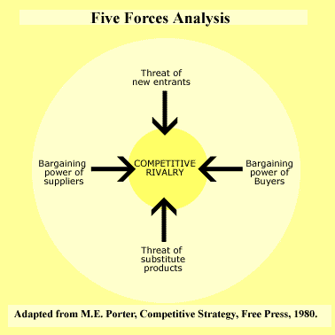

The market for on-line education.

Place the following eight points onto the five forces model:
- Start up costs is very low.
  - Risk of entry by potential competitors
- Students have access to books, videos, and paper-based distance learning packs.
  - Bargain power of buyers / threat of substitutes
- Companies, governments, and self-funding students invest huge amounts in their education.
  - Intensity of rivalry among established firms / bargain power of suppliers
- There are very few high quality web sites available.
  - Bargain power of suppliers
- Traditional colleges and universities are adapting their products for on-line learning.
  - Bargain power of suppliers / risk of entry by potential competitors
- Government legislation in the US and Europe encourages on-line learning.
  - Bargain power of suppliers / risk of entry by potential competitors
- The more innovative learning sites give lesson for free just for the love of it.
  - Threat of substitutes / risk of entry by potential competitors
- More people with access to the web every second.
  - Bargain power of buyers

